#include <iostream.h>

#include <conio.h>

#include <math.h>

int main()

{

int merk;

int motor;

int harga;

int jumlah;

int sisa;

int tenor;

int cicilan;

int hargadp;

int dp = 700000;

float bunga = 0.1;

cout<<"Selamat Datang";

cout<<endl;

cout<<endl;

cout<<"Merk Motor: ";

cout<<endl;

cout<<"1. Honda ";

cout<<endl;

cout<<" 1. CRF 150L Rp 32.000.000";

cout<<endl;

cout<<" 2. CBR 150R (Street Fire) Rp 26.500.000";

cout<<endl;

cout<<" 3. CBR 150R Rp 33.500.000";

cout<<endl;

cout<<" 4. Sonic 150R Rp 22.400.000";

cout<<endl;

cout<<" 5. CB 150 Verza Rp 19.500.000";

cout<<endl;

cout<<" 6. CBR 250RR Rp 70.000.000";

cout<<endl;

cout<<endl;

cout<<"2. Yamaha";

cout<<endl;

cout<<" 1. All New Vixion Rp 26.500.000";

cout<<endl;

cout<<" 2. Xabre New Color Rp 30.700.000";

cout<<endl;

cout<<" 3. MT-25 Rp 48.000.000";

cout<<endl;

cout<<" 4. All New R-15 Rp 35.500.000";

cout<<endl;

cout<<" 5. R-25 Rp 57.000.000";

cout<<endl;

cout<<endl;

cout<<"3. Suzuki";

cout<<endl;

cout<<" 1. All New Satria F150 Rp 22.500.000";

cout<<endl;

cout<<" 2. GSX-S150 Rp 25.000.000";

cout<<endl;

cout<<" 3. GSX-R150 Rp 30.000.000";

cout<<endl;

cout<<endl;

cout<<"4. Kawasaki";

cout<<endl;

cout<<" 1. Z 125 Pro Rp 32.500.000";

cout<<endl;

cout<<" 2. Z 250 (ABS) Rp 60.600.000";

cout<<endl;

cout<<" 3. Ninja 250 SL Rp 45.300.000";

cout<<endl;

cout<<" 4. Ninja 250 SE Rp 71.900.000";

cout<<endl;

cout<<endl;

cout<<"Silahkan Pilih Merk: ";

cin>>merk;

switch (merk)

{

case 1:

{

cout<<"Honda";

cout<<endl;

cout<<"Masukan Tipe Motor: ";

cin>>motor;

switch (motor)

{

case 1:

{

cout<<"CRF 150L(Rp 32.000.000)";

cout<<endl;

cout<<"Masukan Harga Motor: ";

cin>>harga;

cout<<"Masukan Jumlah Pembelian: ";

cin>>jumlah;

cout<<"Masukan Tenor: ";

cin>>tenor;

hargadp = dp-harga;

cicilan = hargadp/tenor + bunga\*hargadp;

sisa = cicilan\*tenor;

cout<<"Sisa Pembayaran: "<<sisa;

cout<<endl;

break;

}

case 2:

{

cout<<"CBR 150R (Street Fire)(Rp 26.500.000)";

cout<<endl;

cout<<"Masukan Harga Motor: ";

cin>>harga;

cout<<"Masukan Jumlah Pembelian: ";

cin>>jumlah;

cout<<"Masukan Tenor: ";

cin>>tenor;

hargadp = dp-harga;

cicilan = hargadp/tenor + bunga\*hargadp;

sisa = cicilan\*tenor;

cout<<"Sisa Pembayaran: "<<sisa;

cout<<endl;

break;

}

case 3:

{

cout<<"CBR 150R(Rp 33.500.000)";

cout<<endl;

cout<<"Masukan Harga Motor: ";

cin>>harga;

cout<<"Masukan Jumlah Pembelian: ";

cin>>jumlah;

cout<<"Masukan Tenor: ";

cin>>tenor;

hargadp = dp-harga;

cicilan = hargadp/tenor + bunga\*hargadp;

sisa = cicilan\*tenor;

cout<<"Sisa Pembayaran: "<<sisa;

cout<<endl;

break;

}

case 4:

{

cout<<"Sonic 150R(Rp 22.400.000)";

cout<<endl;

cout<<"Masukan Harga Motor: ";

cin>>harga;

cout<<"Masukan Jumlah Pembelian: ";

cin>>jumlah;

cout<<"Masukan Tenor: ";

cin>>tenor;

hargadp = dp-harga;

cicilan = hargadp/tenor + bunga\*hargadp;

sisa = cicilan\*tenor;

cout<<"Sisa Pembayaran: "<<sisa;

cout<<endl;

break;

}

case 5:

{

cout<<"CB 150 Verza(Rp 19.500.000)";

cout<<endl;

cout<<"Masukan Harga Motor: ";

cin>>harga;

cout<<"Masukan Jumlah Pembelian: ";

cin>>jumlah;

cout<<"Masukan Tenor: ";

cin>>tenor;

hargadp = dp-harga;

cicilan = hargadp/tenor + bunga\*hargadp;

sisa = cicilan\*tenor;

cout<<"Sisa Pembayaran: "<<sisa;

cout<<endl;

break;

}

case 6:

{

cout<<"CBR 250RR(Rp 70.000.000)";

cout<<endl;

cout<<"Masukan Harga Motor: ";

cin>>harga;

cout<<"Masukan Jumlah Pembelian: ";

cin>>jumlah;

cout<<"Masukan Tenor: ";

cin>>tenor;

hargadp = dp-harga;

cicilan = hargadp/tenor + bunga\*hargadp;

sisa = cicilan\*tenor;

cout<<"Sisa Pembayaran: "<<sisa;

cout<<endl;

break;

}

}

break;

}

case 2:

{

cout<<"Yamaha";

cout<<endl;

cout<<"Masukan Tipe Motor: ";

cin>>motor;

switch (motor)

{

case 1:

{

cout<<"All New Vixion(Rp 26.500.000)";

cout<<endl;

cout<<"Masukan Harga Motor: ";

cin>>harga;

cout<<"Masukan Jumlah Pembelian: ";

cin>>jumlah;

cout<<"Masukan Tenor: ";

cin>>tenor;

hargadp = dp-harga;

cicilan = hargadp/tenor + bunga\*hargadp;

sisa = cicilan\*tenor;

cout<<"Sisa Pembayaran: "<<sisa;

cout<<endl;

break;

}

case 2:

{

cout<<"Xabre New Color (Rp 30.700.000)";

cout<<endl;

cout<<"Masukan Harga Motor: ";

cin>>harga;

cout<<"Masukan Jumlah Pembelian: ";

cin>>jumlah;

cout<<"Masukan Tenor: ";

cin>>tenor;

hargadp = dp-harga;

cicilan = hargadp/tenor + bunga\*hargadp;

sisa = cicilan\*tenor;

cout<<"Sisa Pembayaran: "<<sisa;

cout<<endl;

break;

}

case 3:

{

cout<<"MT-25 (Rp 48.000.000)";

cout<<endl;

cout<<"Masukan Harga Motor: ";

cin>>harga;

cout<<"Masukan Jumlah Pembelian: ";

cin>>jumlah;

cout<<"Masukan Tenor: ";

cin>>tenor;

hargadp = dp-harga;

cicilan = hargadp/tenor + bunga\*hargadp;

sisa = cicilan\*tenor;

cout<<"Sisa Pembayaran: "<<sisa;

cout<<endl;

break;

}

case 4:

{

cout<<"All New R-15 (Rp 35.500.000)";

cout<<endl;

cout<<"Masukan Harga Motor: ";

cin>>harga;

cout<<"Masukan Jumlah Pembelian: ";

cin>>jumlah;

cout<<"Masukan Tenor: ";

cin>>tenor;

hargadp = dp-harga;

cicilan = hargadp/tenor + bunga\*hargadp;

sisa = cicilan\*tenor;

cout<<"Sisa Pembayaran: "<<sisa;

cout<<endl;

break;

}

case 5:

{

cout<<"R25 (Rp 57.000.000)";

cout<<endl;

cout<<"Masukan Harga Motor: ";

cin>>harga;

cout<<"Masukan Jumlah Pembelian: ";

cin>>jumlah;

cout<<"Masukan Tenor: ";

cin>>tenor;

hargadp = dp-harga;

cicilan = hargadp/tenor + bunga\*hargadp;

sisa = cicilan\*tenor;

cout<<"Sisa Pembayaran: "<<sisa;

cout<<endl;

break;

}

}

break;

}

case 3:

{

cout<<"Suzuki";

cout<<endl;

cout<<"Masukan Tipe Motor: ";

cin>>motor;

switch (motor)

{

case 1:

{

cout<<"All New Satria F150(Rp 22.500.000)";

cout<<endl;

cout<<"Masukan Harga Motor: ";

cin>>harga;

cout<<"Masukan Jumlah Pembelian: ";

cin>>jumlah;

cout<<"Masukan Tenor: ";

cin>>tenor;

hargadp = dp-harga;

cicilan = hargadp/tenor + bunga\*hargadp;

sisa = cicilan\*tenor;

cout<<"Sisa Pembayaran: "<<sisa;

cout<<endl;

break;

}

case 2:

{

cout<<"GSX-S150(Rp 25.000.000)";

cout<<endl;

cout<<"Masukan Harga Motor: ";

cin>>harga;

cout<<"Masukan Jumlah Pembelian: ";

cin>>jumlah;

cout<<"Masukan Tenor: ";

cin>>tenor;

hargadp = dp-harga;

cicilan = hargadp/tenor + bunga\*hargadp;

sisa = cicilan\*tenor;

cout<<"Sisa Pembayaran: "<<sisa;

cout<<endl;

break;

}

case 3:

{

cout<<"GSX-R150(Rp 30.000.000)";

cout<<endl;

cout<<"Masukan Harga Motor: ";

cin>>harga;

cout<<"Masukan Jumlah Pembelian: ";

cin>>jumlah;

cout<<"Masukan Tenor: ";

cin>>tenor;

hargadp = dp-harga;

cicilan = hargadp/tenor + bunga\*hargadp;

sisa = cicilan\*tenor;

cout<<"Sisa Pembayaran: "<<sisa;

cout<<endl;

break;

}

}

break;

}

case 4:

{

cout<<"Kawasaki";

cout<<endl;

cout<<"Masukan Tipe Motor: ";

cin>>motor;

switch (motor)

{

case 1:

{

cout<<"Z 125 pro(Rp 32.500.000)";

cout<<endl;

cout<<"Masukan Harga Motor: ";

cin>>harga;

cout<<"Masukan Jumlah Pembelian: ";

cin>>jumlah;

cout<<"Masukan Tenor: ";

cin>>tenor;

hargadp = dp-harga;

cicilan = hargadp/tenor + bunga\*hargadp;

sisa = cicilan\*tenor;

cout<<"Sisa Pembayaran: "<<sisa;

cout<<endl;

break;

}

case 2:

{

cout<<"Z 250 (ABS)(Rp 60.000.000)";

cout<<endl;

cout<<"Masukan Harga Motor: ";

cin>>harga;

cout<<"Masukan Jumlah Pembelian: ";

cin>>jumlah;

cout<<"Masukan Tenor: ";

cin>>tenor;

hargadp = dp-harga;

cicilan = hargadp/tenor + bunga\*hargadp;

sisa = cicilan\*tenor;

cout<<"Sisa Pembayaran: "<<sisa;

cout<<endl;

break;

}

case 3:

{

cout<<"Ninja 250SL(Rp 45.300.000)";

cout<<endl;

cout<<"Masukan Harga Motor: ";

cin>>harga;

cout<<"Masukan Jumlah Pembelian: ";

cin>>jumlah;

cout<<"Masukan Tenor: ";

cin>>tenor;

hargadp = dp-harga;

cicilan = hargadp/tenor + bunga\*hargadp;

sisa = cicilan\*tenor;

cout<<"Sisa Pembayaran: "<<sisa;

cout<<endl;

break;

}

case 4:

{

cout<<"Ninja 250 SE(Rp 71.900.000)";

cout<<endl;

cout<<"Masukan Harga Motor: ";

cin>>harga;

cout<<"Masukan Jumlah Pembelian: ";

cin>>jumlah;

cout<<"Masukan Tenor: ";

cin>>tenor;

hargadp = dp-harga;

cicilan = hargadp/tenor + bunga\*hargadp;

sisa = cicilan\*tenor;

cout<<"Sisa Pembayaran: "<<sisa;

cout<<endl;

break;

}

}

break;

}

default:

{

cout<<"Pilihan Tidak Terdaftar";

cout<<endl;

}

} //Close scope untuk switch (merk)

getch();

return 0;

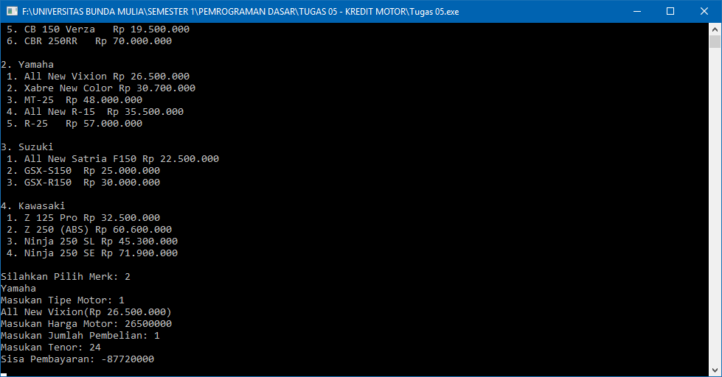} //Close scope untuk .cpp